From: http://www.slate.com/blogs/lexicon_valley/2016/09/12/hillary_s_basket_of_deplorables_has_some_fascinating_legal_antecedents.html

A BLOG ABOUT LANGUAGE
SEPT. 12 2016 11:36 AM

Where Did Hillary Get a Phrase Like “Basket of Deplorables”?
406
173
110
By Ben Zimmer
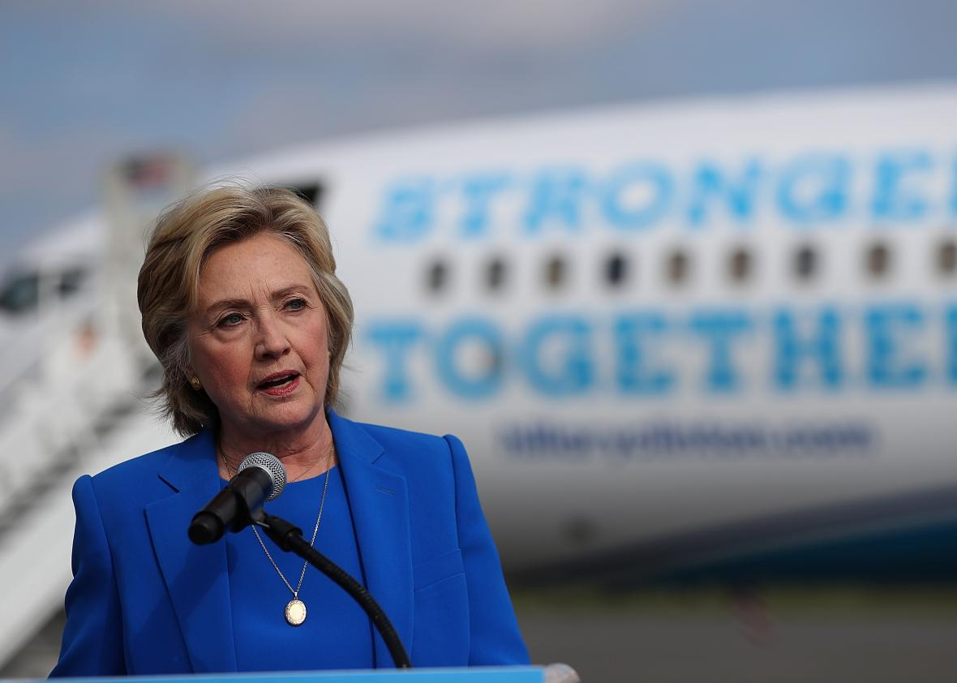
Hillary Clinton.
Justin Sullivan/Getty Images
Hillary Clinton's "basket of deplorables" is destined to become one of the lasting catchphrases of the campaign season.
Clinton's use of the phrase (which she says now she regrets*) appeared in a speech delivered at a fundraiser on Friday night:
You know, to just be grossly generalistic, you could put half of Trump's supporters into what I call the basket of deplorables. Right? The racist, sexist, homophobic, xenophobic, Islamophobic—you name it.
Clinton had deployed the word deplorables at least once before, in an interview on Israeli TV on Thursday with phrasing similar to Friday night's speech:
If I were to be grossly generalistic, I'd say you can take Trump supporters and put them in two big baskets. There are what I call the deplorables.
Deplorables, whether or not they're in baskets, fit a pattern we've observed in the past: adjectives ending in -able or -ible that are turned into pluralizable nouns. Back in 2008, I looked at horribles and terribles as examples of this pattern:
More generally, many adjectives ending in -able/-ible have spawned related noun forms: think of collectibles, convertibles, deductibles, disposables, intangibles, perishables, and unmentionables. Sometimes the noun overtakes the adjective: vegetable comes from an adjective describing something that is able to vegetate, i.e., grow like a plant.
Pluralized horribles have most often occurred in the set phrase "parade of horribles." For a Boston Globe column in 2012, I traced the "parade of horribles" back to mid-19th-century New England, when austere parades of "ancients and honorables" held on Independence Day were spoofed, burlesque-style, as "antiques and horribles." Shore towns in Massachusetts and Rhode Island have continued the satirical tradition, holding "parades of horribles" every year.
Meanwhile, starting in the 1920s, the phrase entered legal usage as a dismissive term for imagined concerns about a ruling's negative effects. Justice Ruth Bader Ginsberg memorably referred to "the broccoli horrible" in her opinion on a 2012 Obamacare ruling. (For more, see my follow-ups to the Globe column on Language Log and Vocabulary.com.)
As Nancy Friedman observed on Twitter, there's a rhyming echo of "parade of horribles" in Clinton's "basket of deplorables." Given Clinton's lawyerly background, it's a good guess that "parade of horribles" inspired her turn of phrase. The plural noun deplorables, however, has far more scattered historical usage in English than horribles. The OED defines deplorables as "deplorable ills" and provides a single citation from the journal of Sir Walter Scott:
1828 Scott Jrnl. 10 Apr. (1941) 222 An old fellow, mauld with rheumatism and other deplorables.
From a few years later, here is an attestation in an 1831 journal entry by Thomas Carlyle, pairing deplorables with despicables:
Of all the deplorables and despicables of this city and time the saddest are the "literary men."
And here's an example from 1901, in a short story published in The Smart Set("Brocton Mott, Realist," by Kate Jordan):
He turned to the east and took a Third avenue car down town. It carried a load of deplorables; all uninteresting, some offensive.
Top Comment
A bucket of brine A chalice of chaff A menagerie of mendicants A plethora of peasants A conclave of klansmen A redoubt of Russians A gathering of gauche A coffle of contemptibles A vat of venomous, vituperative, venal vladimirs More...
110 CommentsJoin In
No word on whether the deplorables in that streetcar were Trump voters.
*As Bloix points out in the comments, Clinton didn't say she regrets using the phrase "basket of deplorables"; rather, she regrets saying that "half of Trump's supporters" could be put in the aforementioned basket.
Update: See this Boston Globe article for more on the spread of the "basket of deplorables" meme. And now Trump has created a commercial called "Deplorables" capitalizing on Clinton's controversial line.
Ben Zimmer is the language columnist for the Wall Street Journal.

From: http://www.slate.com/articles/news_and_politics/politics/2016/11/how_democrats_can_appeal_to_trump_voters.html
POLITICS
WHO'S WINNING, WHO'S LOSING, AND WHY.
NOV. 10 2016 4:09 PM

The Five Baskets of Trump Voters
18.1k
0
4.4k

The deplorables make up only one basket. [Spins Slate! ] If Democrats dismiss the other four, they’ll keep losing elections.
By William Saletan
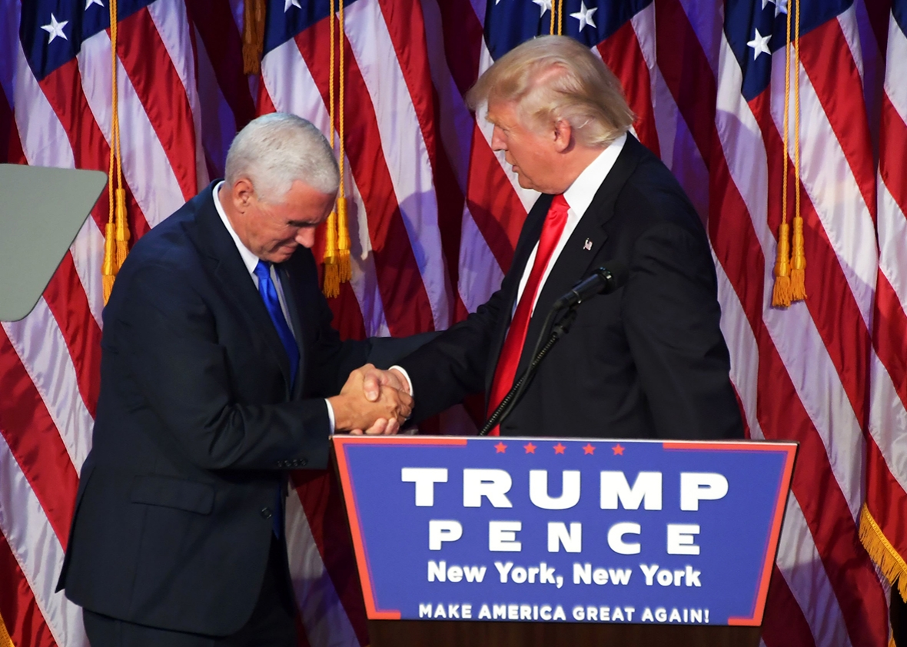
President-elect Donald Trump shakes hands with Vice President–elect Mike Pence during election night in New York on Wednesday.
Jim Watson/Getty Images
You’re sick to your stomach at the results of this election. Maybe, like me, you’ve had trouble sleeping and eating. You can’t believe your country elected a transparent bigot, misogynist, and conman as president of the United States. You can’t believe voters rejected a supremely qualified woman. The people who did this, the people who voted for Donald Trump, are bad people. They’ve declared war on you. They’ve declared war on all of us.
WILLIAM SALETAN
Will Saletan writes about politics, science, technology, and other stuff for Slate. He’s the author of Bearing Right.

This country is full of hate, you tell yourself. Racism, sexism, homophobia, Islamophobia. Did white women vote for Trump? Yes, because they fell for his racism. Did Latino men vote for him? Yes, because they fell for his sexism. We need more education about ethnicity, gender, and diversity. We need to talk more about the racism of white America and the misogyny of our culture.
By all means, talk about these problems. But don’t pretend that’s how you’re going to win the next election. You’ve just seen a brutal demonstration that assailing racism, sexism, homophobia, and Islamophobia is not enough. In some ways, it’s counterproductive. You need a broader message, one that appeals to people regardless of race, sex, or religion. Don’t take it from me. Take it from the woman who just lost.
Two months ago, at a fundraising event in New York City, Hillary Clinton delivered her now-famous remarks about a “basket of deplorables.” Clinton was accused of demonizing and writing off tens of millions of Americans. But that’s not what she said.
[Maybe, but didn’t she speak them?]

Read her words again:
Don’t get complacent. Don’t see the latest outrageous, offensive, inappropriate comment [from Trump] and think, “Well, he’s done this time.” We are living in a volatile political environment. You know, to just be grossly generalistic, you could put half of Trump’s supporters into what I call the basket of deplorables [Basket 1]. Right? The racist, sexist, homophobic, xenophobic, Islamaphobic—you name it. And unfortunately there are people like that. And he has lifted them up. He has given voice to their websites that used to only have 11,000 people, now 11 million. He tweets and retweets their offensive, hateful, mean-spirited rhetoric. Now, some of those folks, they are irredeemable [Basket 2] but thankfully they are not America. …
But that other basket of people are people who feel that the government has let them down, the economy has let them down, nobody cares about them, nobody worries about what happens to their lives and their futures. And they’re just desperate for change. It doesn’t really even matter where it comes from. They don’t buy everything he says, but he seems to hold out some hope that their lives will be different. They won’t wake up and see their jobs disappear, lose a kid to heroin, feel like they’re in a dead end. Those are people we have to understand and empathize with as well.
Clinton wasn’t really talking about the deplorables. She was talking about the [Basket 2] nondeplorables. She was talking about reaching out to those who were attracted to Trump’s promises of help and a better life. She understood that to win, she needed to connect with these people. She needed to draw them away from Trump.
And that’s why Republicans pounced on her remarks. They recognized in the phrase “basket of deplorables” an opportunity to alienate Clinton from white America. They portrayed her as having dismissed all whites as racists, all men as sexists, all Christians as bigots. They wanted to bury her message of economic outreach. They wanted to make the election about identity and about liberal elites smearing the character of white working people.
When we talk about Trump’s voters, we’re really talking about five baskets. The first basket is the deplorables[Basket 1]: people who love to hate. These are the folks who paint swastikas and write racial slurs on Twitter. The second basket [Basket 2?] is people who liked Trump’s vilification of immigrants or agreed with him that Clinton didn’t “look like a president.” They’re easily manipulated. The third basket [Who invented this one?] is people who don’t see racism or sexism anywhere. The fourth basket is people who don’t think it’s a big deal[Who invented this one?]. They shrug off Trump’s taped comments about grabbing women as “locker room talk.” And the fifth basket [Who invented this one?] is people who were genuinely troubled by the way Trump treated women, or the way he talked about a Mexican American judge or the mother of a Muslim American soldier, but who voted for him anyway, or stayed home, because they couldn’t stand Clinton.
If you talk about all these people as though they’re the same thing—if you call them all racists or sexists or bigots or haters—you’ll lose more elections. And you’ll deserve to lose, because by lumping them all together and dismissing them, you’re doing to them what the worst of them have done to you.
Instead, separate the baskets. [Isn’t this what Will Saletan wishes she’e said?!] Ignore the first one. You’re not going to win over these people, and you shouldn’t try to be the kind of party that would. Set the second basket aside and come back to those folks later. They’re educable, but it’ll take a while. Focus on the last three baskets. Try to help these people recognize bias and structural inequality and why those problems matter. If the issue moves them, great. But if it doesn’t, connect with them in other ways. Inspire them with a vision of opportunity. Explain how you can improve their lives. Appeal to values that transcend identity.
That’s what Clinton wanted to do. It’s what Barack Obama did. It’s careful, respectful, and politically smart.
Everything Clinton talked about in the first paragraph of her “deplorables” speech—racism, sexism, homophobia, xenophobia, Islamaphobia—is real. Trump exploited these prejudices, and I spent most of the election writing about them. As a country, we have a lot of work to do on them. But they can’t be the central message of the Democratic Party. And they can’t be the guiding explanation of why we lost.
That doesn’t mean we shouldn’t talk about race, gender, religion, or homophobia. We should. But we’ve just seen, in the cruelest way, that these issues aren’t enough. Even when the Republican nominee exploits bigotry of all kinds, and even when his opponent would be the first woman president, they aren’t enough. Too many voters—white, male, Christian, or otherwise—don’t care enough about those issues. We can’t afford to lose all these people. We certainly can’t afford to alienate them.

From: http://www.politifact.com/truth-o-meter/article/2016/sep/11/context-hillary-clinton-basket-deplorables/
Hillary Clinton spoke at a fundraiser on Sept. 9, 2016, in New York City.
The Donald Trump campaign is slamming Hillary Clinton for saying that half of Trump’s supporters belong in a "basket of deplorables."
Speaking at the LGBT for Hillary Gala in New York City on Sept. 9, 2016, Clinton said that Trump’s supporters were "racist, sexist, homophobic, xenophobic, Islamaphobic." Trump said the remarks showed "her true contempt for everyday Americans."
We wanted to present Clinton’s comments in context to let readers judge for themselves. We also include her subsequent statement on her comments.
Clinton began the night with a standard welcome before criticizing Trump and the types of judges he might appoint to the U.S. Supreme Court if he were elected. She then noted that she had "a special commitment" to LGBT community and spoke in support of gay rights:
"In too many places still, LGBT Americans are singled out for harassment and violence. You can get married on Saturday, post your pictures on Sunday and get fired on Monday. That's why we've got to continue the forward march of progress."
"And we cannot do it alone. I cannot do it alone. I'm not like Donald Trump, who says, 'I alone can fix it.' I've never quite figured out what it is he alone can fix. But that's not what you'll hear from me. I think we have to do this together. So, together we're gonna pass the Equality Act to guarantee full equality. We're going to put comprehensive quality affordable healthcare within reach for more people, including for mental health and addiction. We're going to take on youth homelessness, and as my wonderful, extraordinary, great daughter said, we are going to end the cruel and dangerous practice of conversion therapy. We're going to keep working toward an AIDS-free generation, a goal that I set as secretary of state, and with your help we're going to pass comprehensive gun laws. ..."
"I know there are only 60 days left to make our case -- and don't get complacent, don't see the latest outrageous, offensive, inappropriate comment and think, well, he's done this time. We are living in a volatile political environment. You know, to just be grossly generalistic, you could put half of Trump's supporters into what I call the basket of deplorables. Right? The racist, sexist, homophobic, xenophobic, Islamaphobic -- you name it. And unfortunately there are people like that. And he has lifted them up. He has given voice to their websites that used to only have 11,000 people -- now 11 million. He tweets and retweets their offensive hateful mean-spirited rhetoric. Now, some of those folks -- they are irredeemable, but thankfully they are not America."
"But the other basket -- and I know this because I see friends from all over America here -- I see friends from Florida and Georgia and South Carolina and Texas -- as well as, you know, New York and California -- but that other basket of people are people who feel that the government has let them down, the economy has let them down, nobody cares about them, nobody worries about what happens to their lives and their futures, and they're just desperate for change. It doesn't really even matter where it comes from. They don't buy everything he says, but he seems to hold out some hope that their lives will be different. They won't wake up and see their jobs disappear, lose a kid to heroin, feel like they're in a dead-end. Those are people we have to understand and empathize with as well."
[(Abrupt change of subject at this point, it appears.)]
"And what I hope is that in addition to your extraordinary generosity, you will go to our website, hillaryclinton.com, or text to join at 47246 to see how else you can get involved."
Clinton continued to ask people to get involved with her campaign, then introduced singer Barbra Streisand.
The next day, after facing criticism from the Trump campaign and others, Clinton issued this statement:
"Last night I was ‘grossly generalistic,’ and that's never a good idea. I regret saying ‘half’ -- that was wrong. But let's be clear, what's really ‘deplorable’ is that Donald Trump hired a major advocate for the so-called ‘alt-right’ movement to run his campaign and that David Duke and other white supremacists see him as a champion of their values. It's deplorable that Trump has built his campaign largely on prejudice and paranoia and given a national platform to hateful views and voices, including by retweeting fringe bigots with a few dozen followers and spreading their message to 11 million people. It's deplorable that he's attacked a federal judge for his ‘Mexican heritage,’ bullied a Gold Star family because of their Muslim faith, and promoted the lie that our first black president is not a true American. So I won't stop calling out bigotry and racist rhetoric in this campaign. I also meant what I said last night about empathy, and the very real challenges we face as a country where so many people have been left out and left behind. As I said, many of Trump's supporters are hard-working Americans who just don’t feel like the economy or our political system are working for them. I'm determined to bring our country together and make our economy work for everyone, not just those at the top. Because we really are ‘stronger together.’ "

